# Exercise: jQuery Plugins

Problems for exercises and homework for the ["JavaScript For Front-End Course @ SoftUni"](https://softuni.bg/trainings/2032/javascript-for-front-end-july-2018#lesson-8965).

You are allowed to change the **HTML** and **CSS** in all exercises.

Archive your solutions and upload them in [course page](https://softuni.bg/trainings/2032/javascript-for-front-end-july-2018#lesson-8969).

## Slick Slider

You are given the **HTML** and **CSS**. Use the jQuery [Slick Slider](http://kenwheeler.github.io/slick/) plugin to implement the task stated below.

Import the **plugin files** into your **project folders**. Your **project structure** should look like this:

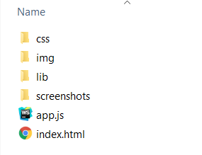

You are also given an empty **JavaScript** file, in which you must write your code:

|  |
| --- |
| app.js |
| ***// TODO: Implement me...*** |

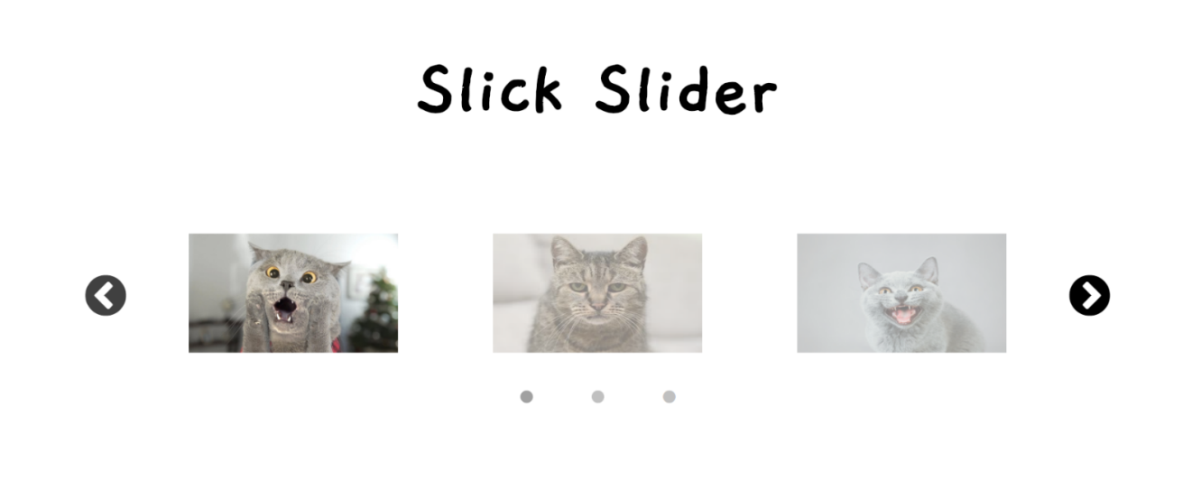

## Date & Time Picker

You are given the **HTML** and **CSS**. Use the jQuery [Date & Time Picker](https://xdsoft.net/jqplugins/datetimepicker/) plugin to implement the task stated below.

You are also given an empty **JavaScript** file, in which you must write your code:

|  |
| --- |
| app.js |
| ***// TODO: Implement me...*** |

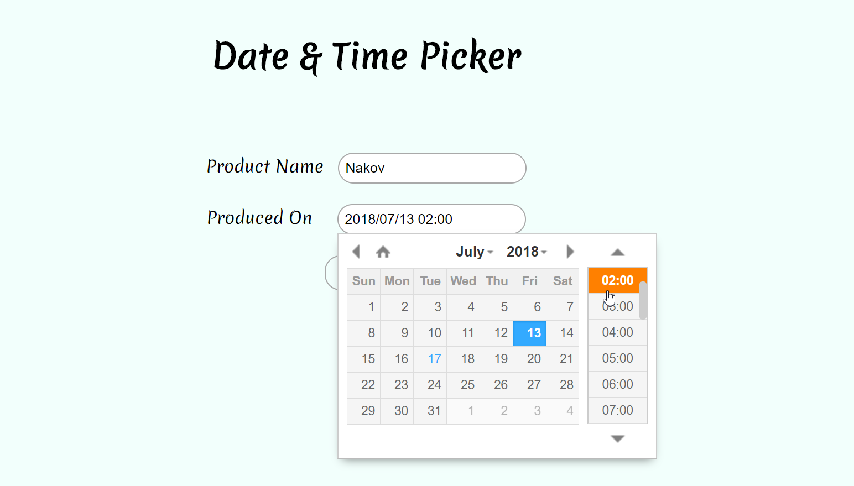

## Form Validator

You are given the **HTML** and **CSS**. Use the jQuery [Form Validator](http://www.formvalidator.net/) plugin to implement the task stated below.

You are also given an empty **JavaScript** file, in which you must write your code:

|  |
| --- |
| app.js |
| ***// TODO: Implement me...*** |

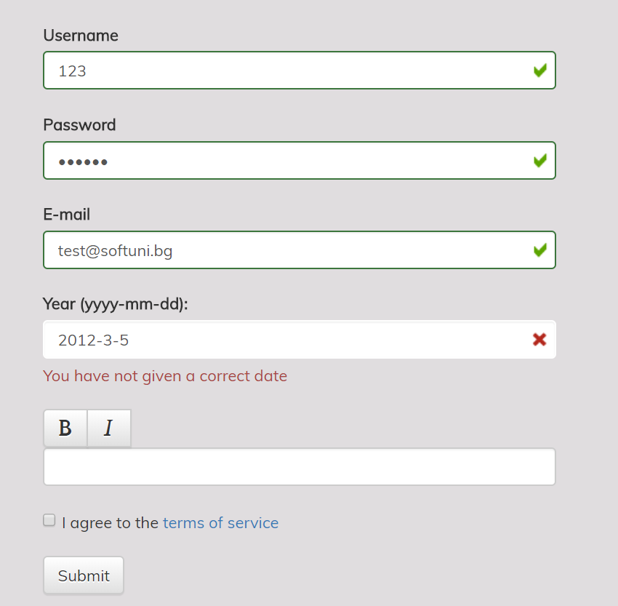 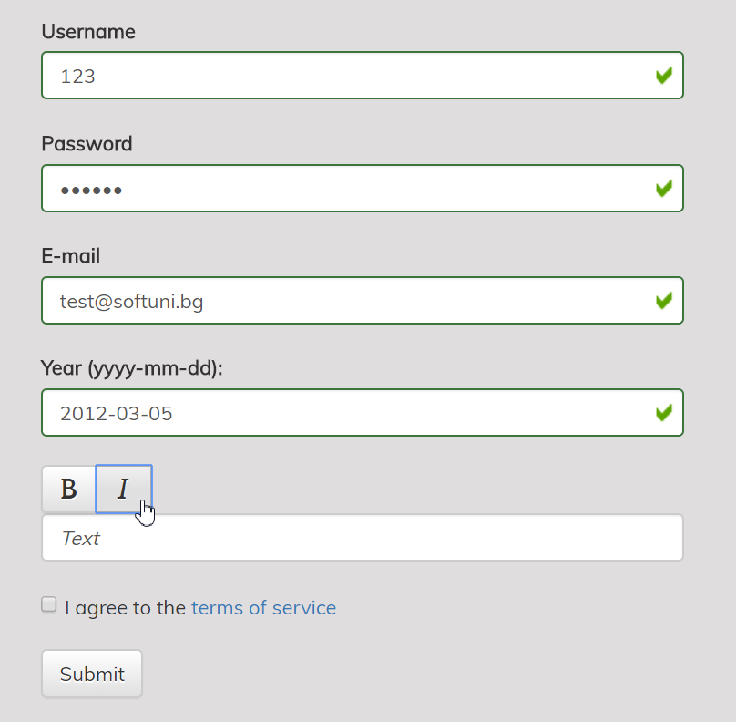

## Table Grid

You are given the **HTML** and **CSS**. Use the jQuery [Table Grid](https://datatables.net/) plugin to implement the task stated below.

You are also given an empty **JavaScript** file, in which you must write your code:

|  |
| --- |
| app.js |
| ***// TODO: Implement me...*** |

